Fee Report System

**Submitted To:**

**Prof.Sakkaravarthi Ramanathan**

**Submitted By:**

**Vijay Tahelramani - 1892593**

**Jayesh Harsiyani - 1893343**

Fees Report System

* Objective:
* The main objective of the Fees Report System is to compute the fees of student studying in the institution.
* The objective also includes searching of a particular student easy and less time consuming than the traditional method where the records were maintained by hand and searching involved hours.
* Updating and Deleting the records of student becomes much easier, simpler and less time consuming.
* Existing solutions:
* The existing manual system used to maintain records of the student on paper, which was an unreliable source:
* Traditional method of maintaining the records was very time consuming.
* Earlier method were very costly and error prone.
* If the records were wrongly entered then it was very difficult to verify them.
* Requires a large amount of manual laborers.
* Your Proposed approach:
* Main feature of the system includes Login, store the details of accountant and student and also generate the Fees report.
* Students can access the system with register into system and see their fees report and also pay due fees.
* There are the two main user of the system admin and accountant :
  + Admin can add, view, update and delete the details of accountant.
  + The main feature of the accountant in the system is to add, update, delete and view the details of Student and generate the fees report according to the details stored in the database.
* There is a fast retrieval of data and a lot of time saved.
* The records can be easily maintained by anyone.
* Records can be easily added to the database and relevant records get updated simultaneously.
* Main advantages of system :
  + To keep the record of the each student studying in the institution.
  + Holds the information about the fees of each of the student.
  + The system helps to manipulate the record of the student without any problem and by easier methods and ways.
  + Anyone with the knowledge of computers, and with authentic password can make changes in the records of the students update them through the system facility.
* Algorithm design:
  + Admin :

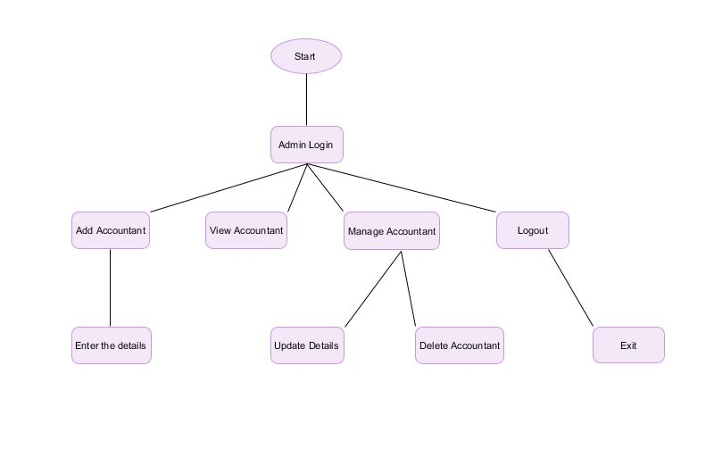

* + Accountant :

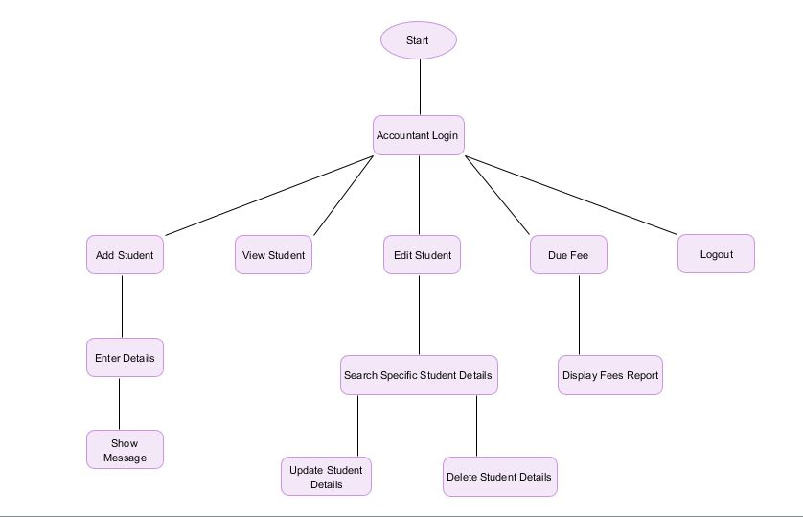

* + Student : 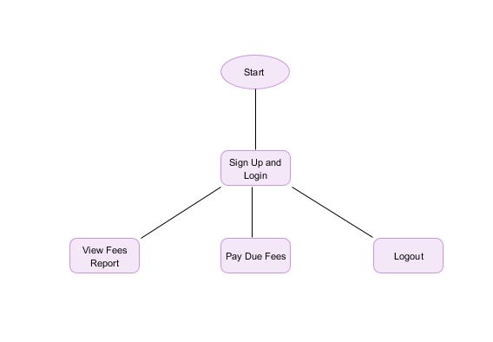
* Implementation:
* Software used to build the project :
  + IDE Eclipse
  + SQLite act as a Database
* Screenshot

Screen Shot of Main Code

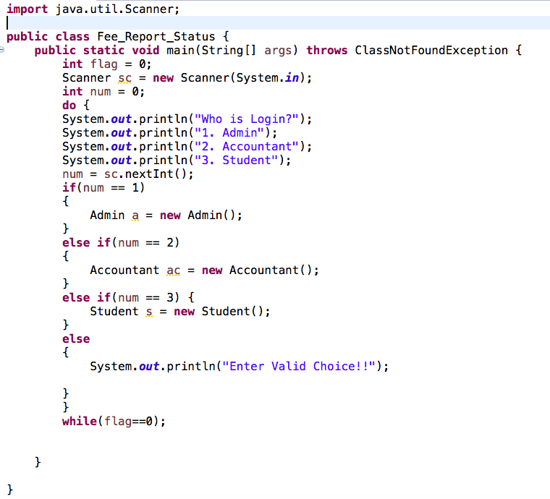

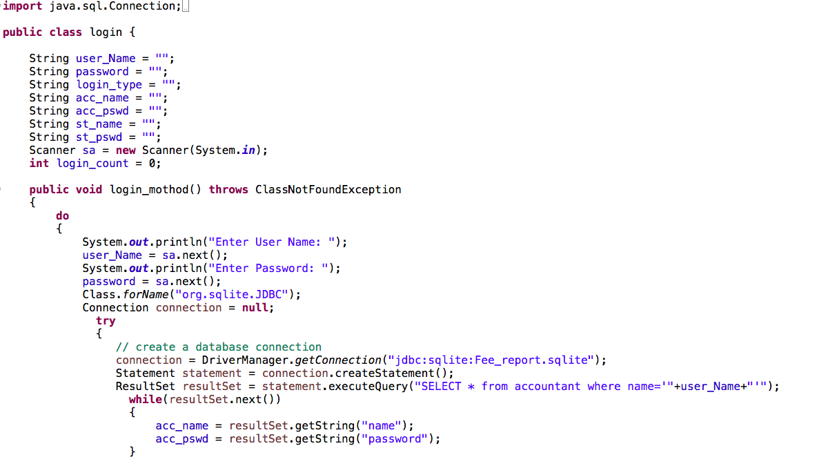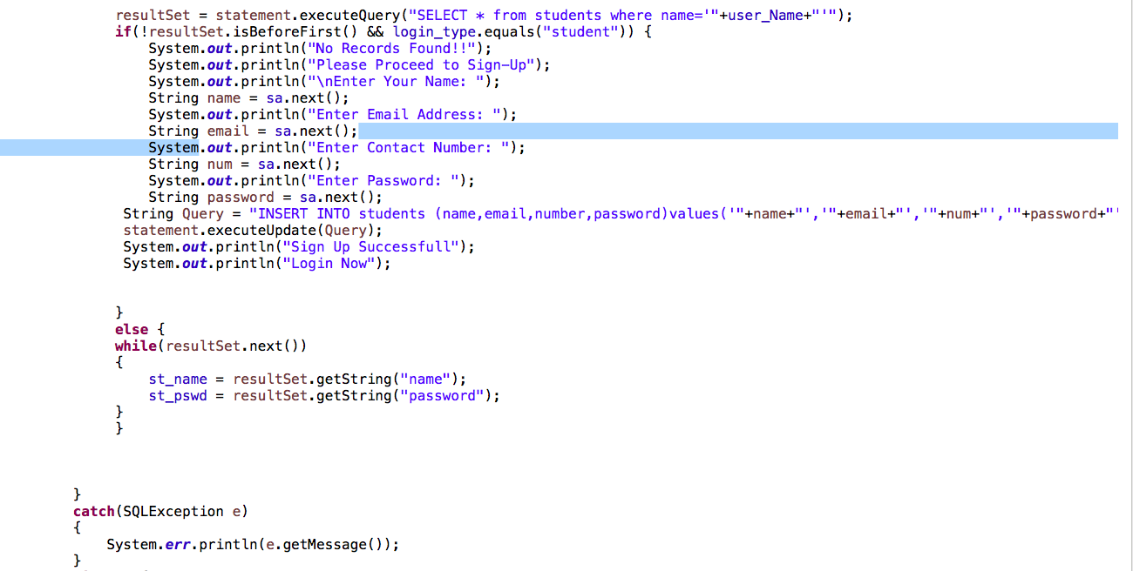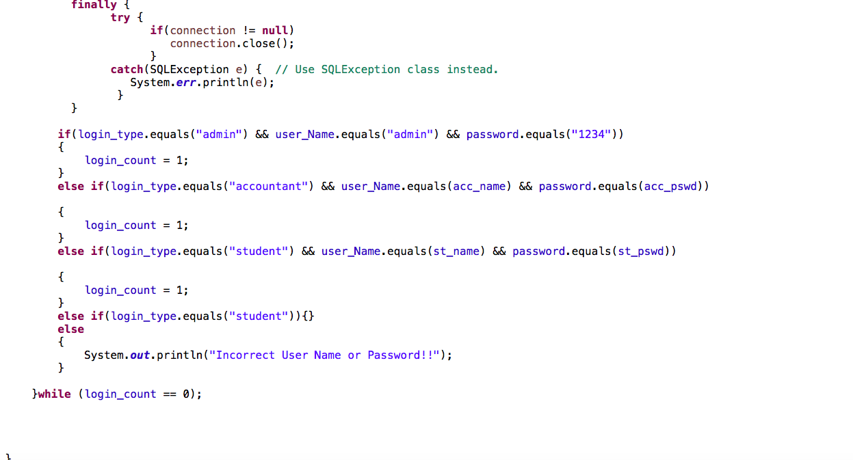

Main Output

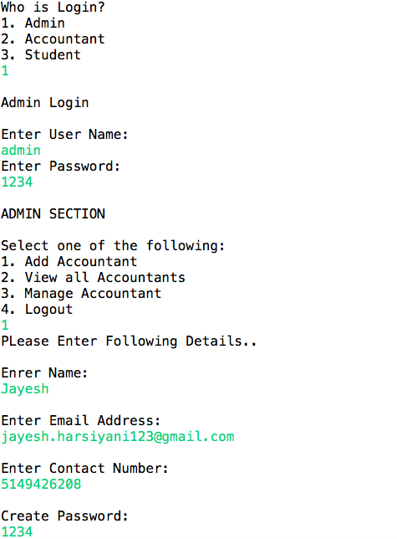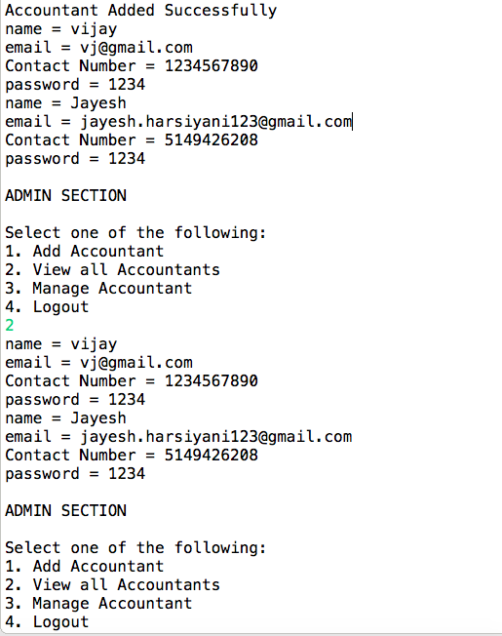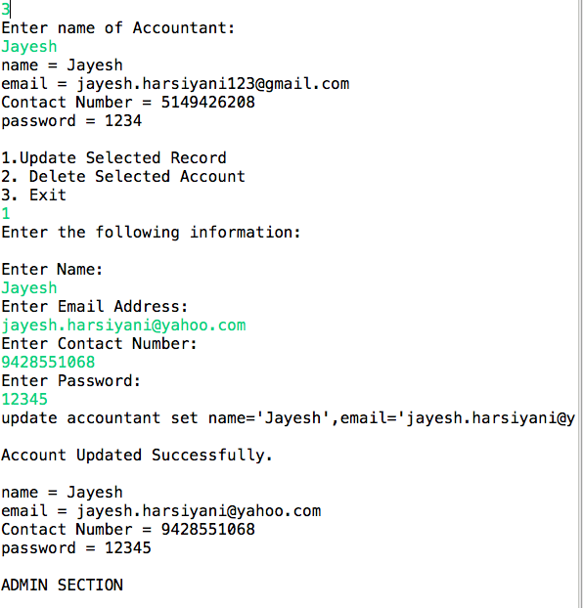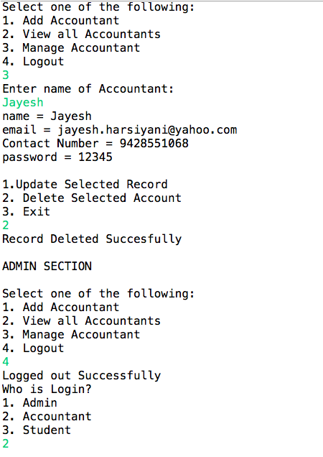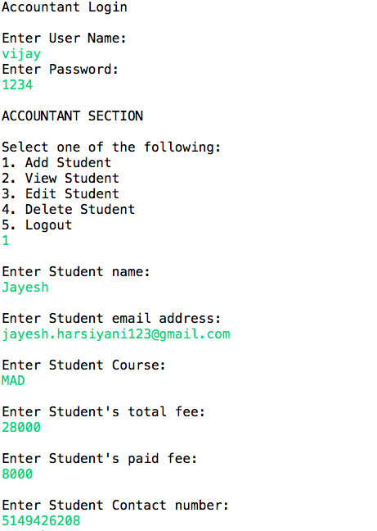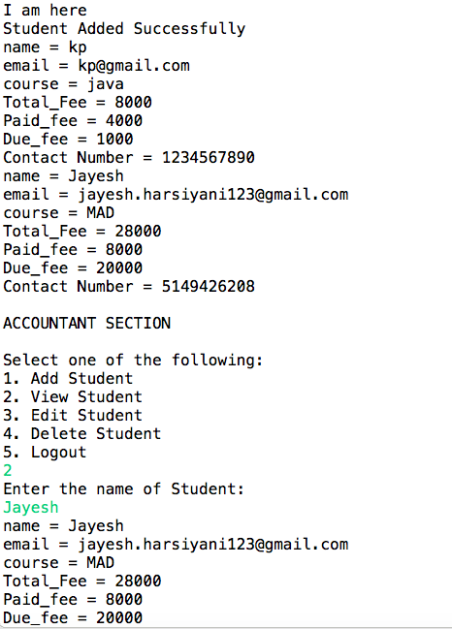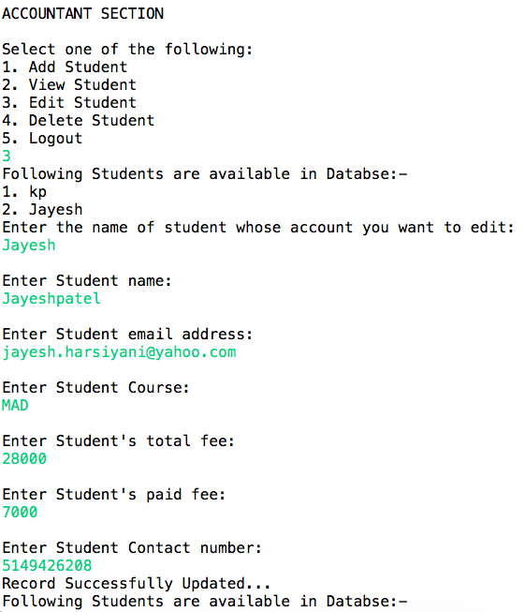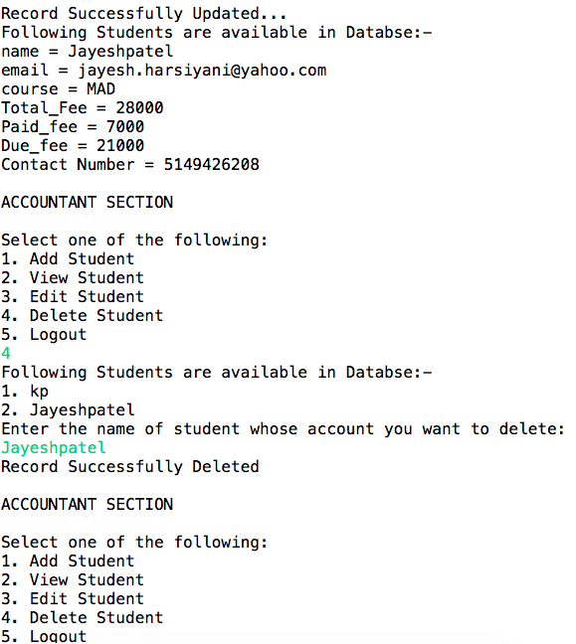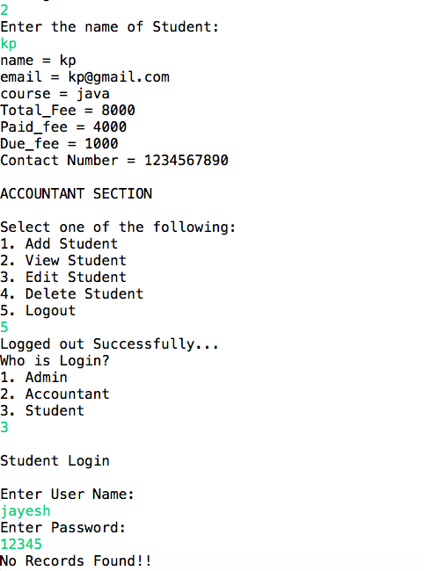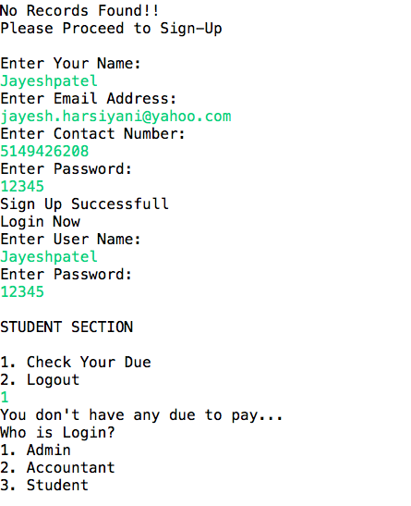

* Conclusion:
* The entire project was developed and deployed in basic OOP concepts with the basic sql and database operation. The project is bug free as per the testing standards that are implemented. Its is an user friendly for the customers or Users.